**\*More methods and info are available on the docs.python.org**

**Python**

1. Python is a simple and easy to understand language that feels like reading simple English
2. Python follows pseudo code nature
3. Features of the python is as follows:
4. Easy to understand =Less development time
5. Free open source
6. High level language
7. Portable – works on windows/Linux/Mac
8. The python file is saved by the extension **.py**, Example <file-name>.py
9. The code for the printing the statement is as shown below:

**print(“This is an demo statment”)**

🡪While we write the print stament in the python the thing in it is started from the new line, And if we want to make the line or statement to be continued on the same line of the above one than we would have to take the help of the end=”” statement at the last as shown in the figure below:

🡺Code:

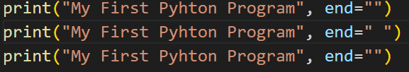

🡺Answer:



**(Chapter-1)** **Modules, Components and pip**

* 1. **Modules**: A module is a file containing code written by somebody else(usually) which can be imported and used in our programs
  2. **Pip**: Pip is the package manager for python you can use the pip to install a module on your system

🡪Example: **pip install flask** 🡪installs flask module

1. Types of the modules:

🡪There are two type of the modules in the python

* 1. Built in modules 🡪 Pre-installed in the python  
     🡪Some examples of the built in modules are os, abc, etc
  2. External modules 🡪 Need to install using the pip  
     🡪Some examples of the external modules are tensorflow, flask, etc

1. We can directly use the python by help of the REPL on the terminal

🡪Example we can use the python as a calculator by typing **“python”+<enter>** on the terminal

🡪And this opens the **REPL** or **Read Evaluate Print Loop**, The example of it is as shown below:  
 

1. **Comments**: comments are used to write something which the programmer does not want to execute

🡪Types of the comments

* 1. Single line comment: Written using **#,** Example

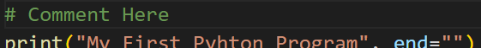

* 1. Multiline comment: Written using **‘’’** comment **‘’’ (Multi-line comment),** Example

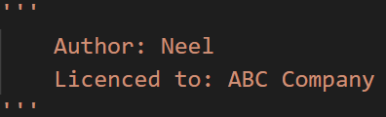

**(Chapter 2) Variables And Datatypes**

**🡪Variables = Container to store the value**

**🡪Keywords = Reserved words in the python**

**🡪Identifiers = Class/Function/Variable name**

**Variable:** A variable is name given to a memory location in a program. For example:

a=30

b=”Harry”

c=71.22

1. **Data Types** : primarily there are following data types in the python:
   1. **Integers**
   2. **Floating Point Numbers**
   3. **Strings**
   4. **Booleans**
   5. **None**

🡪Python is a fantastic language that automatically identifies the type of the data for us

1. a=71 🡪 Identifies a as class<int>
2. b=88.44 🡪 Identifies as class<float>
3. name=”Harry” 🡪 Identifies name as class<Str>

🡪Rules for defining a variable name(Also applies to other identifiers)

1. A variable name can contain alphabets, digits and underscores
2. A variable name can only start with an alphabet and underscore
3. A variable name cannot be started with a digit
4. No space is allowed inside the variable name

🡪Example of the some of variable names are as follow: harry, one8, seven, _Seven, etc

1. **Operators in the python**
   1. Following are some common operators in the python
      1. Arithmetic Operators 🡺 +, - , *, /, etc
      2. Assignment operators 🡺 =, +=, -=, etc
      3. Comparison Operators 🡺 ==, >, >=, <, <=, !=, etc
      4. **Logical Operators 🡺and, or, not**

**🡪Example of the operators are as follow:**

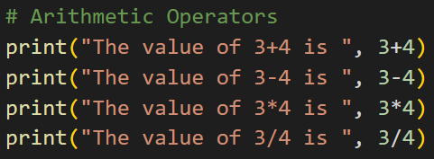

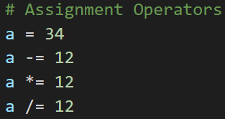

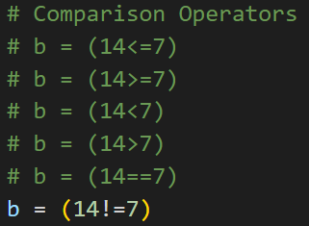

🡪The answer of the comparison comes in the form of the Boolean

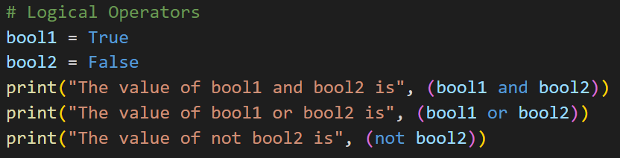

🡪The answer of the above operator comes in the form of the Boolean only

1. **type() function and type casting**

**🡪**type function is used to find the data type of the a given variable in python, Example:

**a=31**

**type(a) 🡺class<int>**

**b=”31”**

**type(b) 🡺class<str>**

🡪A number can be converted into a string and vice versa (if possible), There are many functions to convert one data type into the another

**str(31) 🡺”31”** 🡺integer to String conversion

**int(“32”) 🡺32** 🡺String to integer conversion

**float(32) 🡺 32.0** 🡺Integer to float conversion

…and so on

🡪here the “31” is the string literal and 31 is a numeric literal

1. input() function

🡪This function allows the user to take input from the keyboard **as the string**

**a=input(“Enter the name here”)**

🡪Here the statement would be printed before starting of the scanner

🡪And if there would be no statement than nothing would be printed but the scanner would be started

🡪If the user entered the harry than also the value of the a will be “harry”

🡪It is important to note that the output of the input is always a string(even if the number is entered)

🡪Example of input function is as followed:

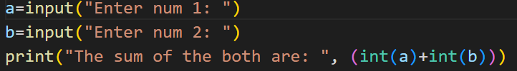

**(Chapter 3) Strings**

* 1. String is a datatype in the python
  2. String is a sequence of characters enclosed in the quotes
  3. We can primarily, write the strings in the three ways
     1. Single quoted strings 🡪a=’Harry’
     2. Double quoted strings 🡪b=”Harry”
     3. Triple quoted strings 🡪c=’’’Harry’’’

🡪The triple quoted strings are only used when we want to take the string containing the more than one line and in it the tabs and spaces are also counted, Example:

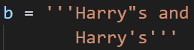

1. **String Slicing**

🡪A string in python can be sliced for getting a part of the string

🡪Consider the following string:

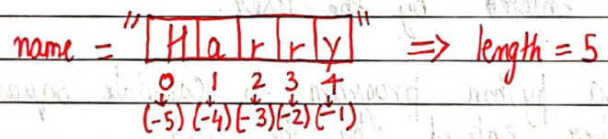

🡪The index in the string starts from the 0 to (length-1) in python. In order to slice a string, We use the following syntax:

**sl=name[ind_start : ind_end]**

**first index included last index is not included**

eg. sl[0 : 3] returns “Har” 🡪Characters from 0 to 3

sl[1 : 3] returns “ar” 🡪Characters from 1 to 3

🡪Some of the example of the string slicing are as follow:

1. Code:

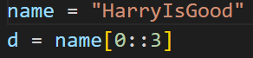

🡪Solution: **Hrso**

1. Code:

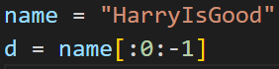

🡪Solution: **dooGsIyrra**

1. **Negative Indices**: Negative indices can also be used as shown in the figure above. -1 corresponds to the (length-1) index, -2 to (length-2)

🡪Slicing with skip value

🡪We can provide the skip value as a part of our slice like this:

**word=”amazing”**

**word[1:6:2] 🡪 ’mzn’**

🡪Other advanced slicing techniques

**word=”amazing”**

**word[ : 7]** 🡪 word[0 : 7] 🡪 ‘amazing’

**word[0 : ]** 🡪 word[0 : 7] 🡪’amazing’

1. **String functions**

Some of the mostly used functions to perform operations on or manipulate strings are:

1. len() function 🡪This function returns the length of the string

Eg. len(“Harry”) 🡪returns 5

1. String.endswith(“rry”) 🡪 This function tells weather the variable string ends with the string “rry” or not. If string is “Harry” it returns true for “rry” since Harry ends with rry
2. String.count(“c”) 🡪 Counts the total number of occurrence of any character
3. String.capitalize() 🡪 This function capitalize the first character of a given string
4. String.find(word) 🡪 This function finds a word and returns the index of first occurrence of that word in the string
5. String.replace(oldWord, newWord) 🡪 This function replaces the old word with the new word with new word in the entire string

🡪Example: 

1. **Escape Sequence Characters**

🡪Sequence of characters after the backslash ‘\’ are called as the escape sequence characters

🡪Escape sequence character comprises of more than one characters but represents one character when used within the strings

Example: **\n, \t, \’, \\**, etc

Example:

🡺Code:

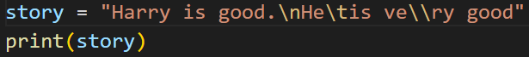

🡺Solution:

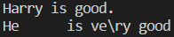

**(Chapter 4) List And Tuples**

1. **Python lists** are containers to store a set of values of any data type

**friends = [“Apple”, “Akash”, “Rohan”, 7, False]**

* 1. In list we can store the value of any datatype
  2. List indexing: A list can be indexed just like a string

**L1 = [7, 9, “Harry”]**

Example:

**L1[0] 🡺 7**

**L1[1] 🡺 9**

**L1[70] 🡺 Error**

**L1[0 : 2] 🡺 [7, 9] 🡺List Slicing**

* 1. List Methods

🡪Consider the following list: **L1=[1, 8, 7, 2, 21, 15]**

* + 1. L1.sort() : Updates the list to [1, 2, 7, 8, 15, 21]
    2. L1.reverse() : Updates the list to [15, 21, 2, 7, 8, 1]
    3. L1.append(8) : adds 8 at the end of the list
    4. L1.insert(3, 8) : This will add 8 at 3rd index
    5. L1.pop(2) : Will delete element at index 2 and return its value
    6. L1.remove(21) : Will remove 21 from the list
  1. Example:

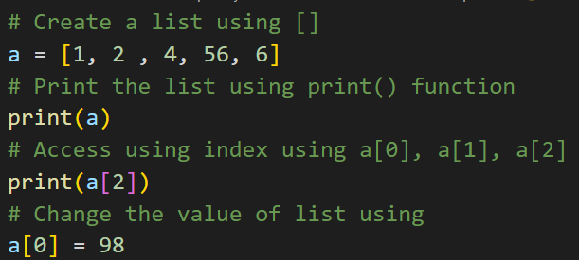

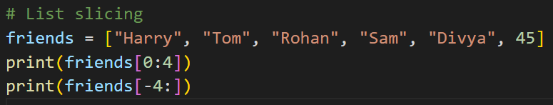

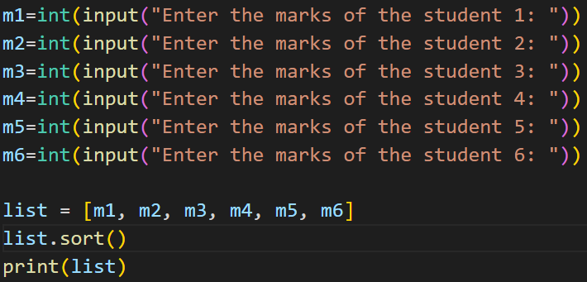

1. Tuples in python
   1. A tuple is an **immutable** data type in python, **That cannot be changed**
   2. Example:

a = () 🡪Empty Tuple

a = (1, ) 🡪Tuple with only one element needs a comma

a = (1, 7, 2) 🡪Tuple with more than one element

* 1. Once defined a tuple’s element cant be altered or manipulated
  2. Tuple’s methods

🡪Consider the following tuple:

a=(1, 7, 2)

1. a.Count(1) : a.Count(1) will return number of times 1 occur in a
2. a.index(1) : a.index(1) will return the index of first occurrence of 1 in a

*The main difference between the list and the tuple is that the tuple cannot be changed and the list can be changed, And the other difference between them is of declaration of the list and tuple

* 1. And if we try to make the change in the tuple as shown in the code below, Than the error would come as shown below of code:

🡪Code:

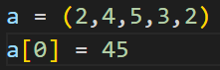

🡪Error:



**(Chapter 5) Dictionary & Sets**

1. **Dictionary** is a collection of key-value pairs

🡪Syntax:

**a = {“Key” : “Value”,**

**“harry” : “Code”,**

**“marks” : “100”,**

**“list” : [1, 2, 9]}**

a[“Key”] 🡺Prints “value”

a[“list”] 🡺 Prints [1, 2, 9]

🡪Properties of python Dictionaries

* 1. It is unordered
  2. It is mutable
  3. It is indexed
  4. Cannot contain duplicate keys

🡪Dictionary Methods

1. a.items() : returns a list of (Key, value) tuples
2. a.keys() : returns a list containing dictionary’s key
3. a.update({“friend” : “Sam”}) : Updates the dictionary with supplied key-value pairs
4. a.get(“name”) : returns the value of the specified keys (and value is returned e.g. “Harry” is returned here)

**\*More methods and info are available on the docs.python.org**

1. **Sets** in python
   1. Set is a collection of non-repetitive elements
   2. Set can be made and the elements can be added in it by help of the following code written below:

**s = Set();**

**s.add(1)**

**s.add(2)**

* 1. Properties of the set is as shown below:
     1. Sets are un-ordered
     2. Sets are un-indexed
     3. There is no way to change items in the sets
     4. Sets cannot contain duplicate values
  2. Operations of the sets
     1. len(s) : Returns the length of the set
     2. s.remove(8) : updates the set S and removes 8 from S
     3. s.pop() : Removes an arbitrary element from the set and returns the element removed
     4. s.clear() : Empties the set S
     5. s.union({8, 11}) : Returns a new set with all items from both sets. i.e. the s and the entered one
     6. s.intersection({8, 11}) : Returns a set which contains only items in both sets i.e. the s and the entered one

**(Chapter 6) Conditional Expressions**

1. In python, we must be able to execute instructions on a conditions being met, This is what condition is for
2. **If, else and elif** statements are a **multiway decision** taken by our program due to certain conditions in out code

**Syntax:**

**if(condition 1):**

🡪If condition 1 is true

🡪If condition 2 is true

🡪Otherwise

**print(“Yes”)**

**elif(condition 2):**

**print(“No”)**

**else:**

**print(“Maybe”)**

1. **Relational Operators**

Relational operators are used to evaluate conditions inside the if statement. Some examples of the relational operators are:

== 🡪 equals

>= 🡪 greater than/equal to

<= 🡪 etc

1. **Logical Operator**

In python logical operators operate on conditional statement, Example:

and 🡪 true if both operands are true else false

or 🡪 true if at least one operand is true else false

not 🡪 inverts true to false & false to true

1. **elif clause**

elif in python means [else if]. An if statement can be chained together with a lot if these elif statements followed by an else statement, Example:

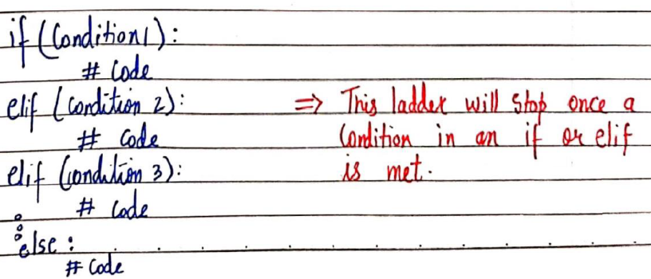

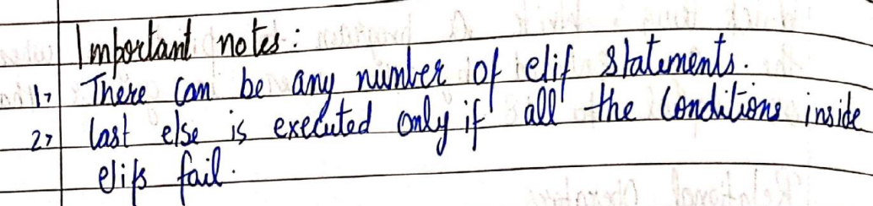

**(Chapter 7) Loops In Python**

1. Sometimes we want to repeat a set of the statement in our programs. For instance: print 1 to 1000

🡪Loops make it easy for a programmer to tell the computer, which set of the instructions to repeat and how!

1. Types of loops in python

Primarily there are two types of loops in python

* 1. While loop
  2. For loop

1. While Loop

🡪Syntax:

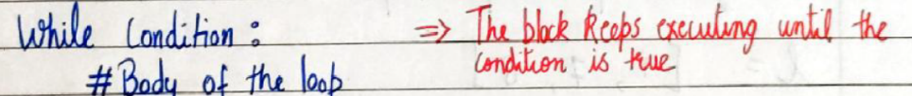

🡪In while loop the condition is checked first. If it evaluates to true, the body of the loop is executed to true, otherwise not

🡪if the loop is entered, the process of [condition, check and execution] is continued until the condition becomes false

🡪Example:

🡪Code

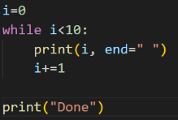

🡪Output



🡪Example of while loop for printing list:

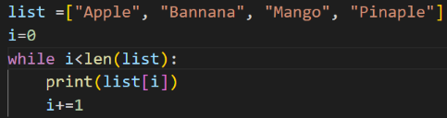

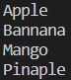

1. For Loop

🡪A for loop is used to iterate through a sequence like list, tuple, or string [iterables]

🡪The syntax of the for loop looks like this:

**l=[1, 7, 8]**

**for item in l :**

**print(item)** 🡪prints 1, 7, 8

🡪Example of while loop for printing list:

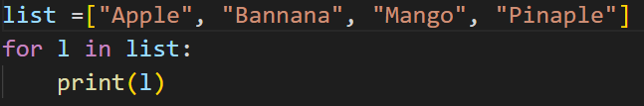

1. **Range function in python**

🡪The range function in python is used to generate a sequence of numbers

🡪We can also specify the start, stop and the step-size in the range function as shown below:

**range(start, stop, step_size)**

🡪Step size is usually not used in the range()

🡪An example of the range function is:

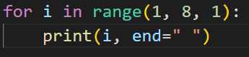

1. **For loop with else**

🡪An optional else can be used with a for loop if the code is to be executed when the loop exhaust

🡪Example:

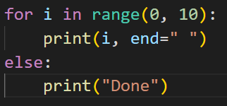

🡪Here the else is executed when the loop exhaust, The output of the above code is as follow:



1. **Break Statement**

🡪’break’ is used to come out of the loop when the encountered, It instructs the program to exit the loop now

🡪Example:

**🡪Code:**

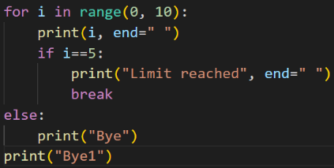

**🡪Output:**



🡪Here when the break statement is used in the for loop and due to that the for loop’s iteration is also made not to be completed, And hence the else block of the code is also not implemented

1. **Continue statement**

🡪’continue’ is used to stop the current iteration of the loop and continue with the next one. It instructs the program to “**Skip the iteration**”

🡪Example:

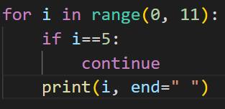

🡪Output



🡪Here in the above code, when the if’s condition is been made true than the continue statement is executed and the code below that statement will be not executed and the next iteration will start

1. **Pass statement**

🡪Pass is a null statement in python, And it instructs to “**Do noting**”

🡪Example:

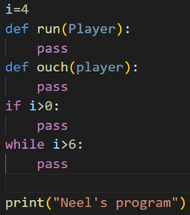

🡪Here the pass statement is used when there is the place where the code is remained to write and the pass statement is used to make that place of the code to not give the error

🡪The output of the above block of the code is :



1. Usage of the f statement in the print statement, By help of which we can enter the value of the any variable of the calculation in the centre of the print statement, Example:

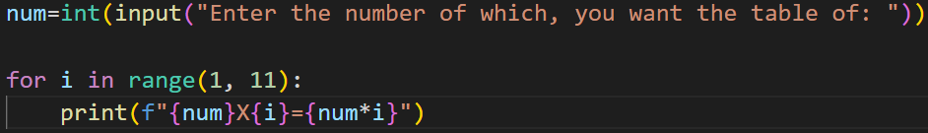

🡪The f statement should be always on the starting on the print’s bracket and before the starting of the **“**, As shown in the figure

🡪And the thing that’s value we want to print should be written in the curly braces(**{…}**), As shown in the figure above

**(Chapter 8) Functions & Recursions**

1. **A function is a group of the statements performing a specific task**

🡪When a program get bigger in size and its complexity grows, it gets difficult for a programmer to keep the track on the which piece of code is doing what, And for this problem the solution is the function

🡪A function can be reused by the programmer in a given program by any number of times

🡪Syntax of the function in python:

**def func1(){**

**print(“Hello”)**

**}**

🡪In python **def** is used to define an function

1. **Function Calling**

Whenever we want to call a function, we put the name of the function followed by the parenthesis as follows:

func1() 🡪This is a function call

1. **Function definition: The part of the exact set of instructions which are executed during the function call**

🡪Types of the function in python:

* 1. **Built in functions**  🡪Already present in python
  2. **User defined functions** 🡪Defined by user

🡪Example of the built in functions includes len(), print(), range()  
🡪**Functions with arguments**: A function can accept some values it can work with. We can put these values in the parenthesis, A function can also return values as shown below:

def greet(name):

gr=”Hello ”+name

return gr

a=greet(“Harry”)

“Harry” is passed to greet name

A will now contain “Hello Harry”

🡪**Default Parameter Value**: We can have a value as default argument in a function

🡪If we specify name=”stranger” in the line containing def, this value is used when no argument is passed

🡪For example:

def greet(name=”stranger”):

#function body

🡪greet() 🡪Name will be “stranger” in function body(default)

🡪greet(“Harry”) 🡪Name will be “Harry” in function body(passed)

1. **Recursion**: Recursion is a function which calls itself, It is used to directly use a mathematical formula as a function. For example:

**factorial(n) = n X factorial(n-1)**

🡪This function can be defined as:

def factorial(n):

if i==0 or i==1:

return 1

else:

return n*factorial(n-1)

Function calling itself

Base condition which doesn’t call the functions any further

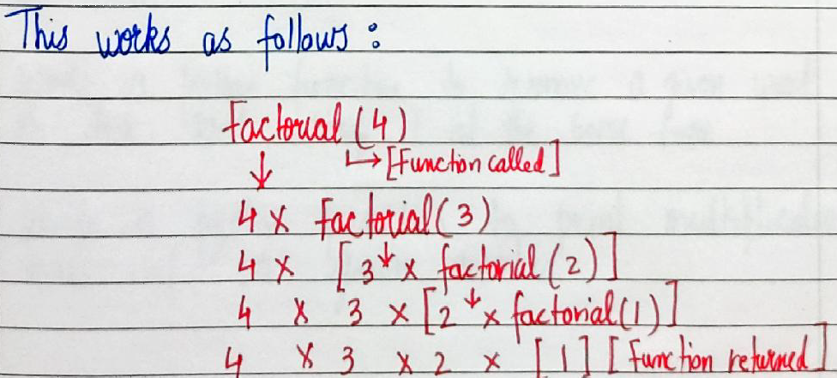

🡪The programmer need to be extremely careful while working with the recursion to ensure that the function doesn’t infinitely keep calling itself. Recursion is sometimes the most directly way to code an algorithm

**(Chapter 9) File Input/Output**

1. The random access memory is volatile and all its content are lost once a program terminates, In order to persists the data forever, we use files

🡪A file is the data stored in a storage device. A python program can talk to the file by reading the content from it and writing content to it

🡪Types of files:

1. Text Files (.text, .c, etc)
2. Binary Files (.jpg, .dat, etc)

🡪Python has a lot of functions for reading, updating and deleting files

🡺Opening a file:

🡪Python has an open() function for opening file. It takes 2 parameters: filename and mode

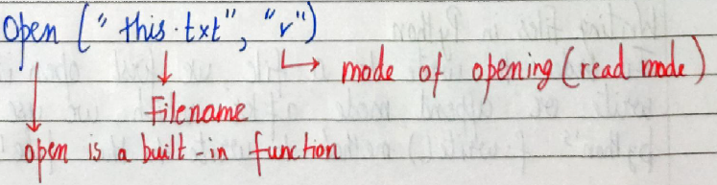

🡺Reading a file:

**f=open(“this.txt”, “r”)** 🡪open file in read mode

**text=f.read()** 🡪Read its content

**print(text)** 🡪Print its content

**f.close()**  🡪Close the file

🡪We can also specify the number of characters in the read() function: f.read(**2**)

🡪Other methods to read the file:

We can also use **f.readLine()** function to read on full line at a time

1. **Mode of opening a file:**
   1. **r** 🡪 Open for reading
   2. **w** 🡪 Open for writing
   3. **a** 🡪 Open for appending
   4. **+** 🡪 Open for updating
   5. ‘**rb**’ will open for read in binary mode
   6. ‘**rt**’ will open for read in text mode
2. Writing files in python

🡪In order to write a file, we first open it in write or append mode after which, we use the python’s f.write() method to write to the file!

Can be called multiple times

f.open(“this.txt”, “w”)

f.write(“This is nice”)

f.close()

🡺with statement

🡪The best way to open and close the file automatically is the **with** statement

with open(“this.txt”) as f:

f.read()

Don’t need to write f.close() as it is done automatically in usage of with statement

**(Chapter 10) Object Oriented Programming(OOPs)**

1. Solving a problem by creating objects is one of the most popular approaches in programming. This is called object oriented programming

🡪The concept of the oops focuses on using reusable code and the oops implements the DRY concept

🡪The meaning of **DRY** concept means **Don’t repeat yourself**

🡺**Class**

🡪A class is a blueprint for creating objects

🡪Syntax of class:

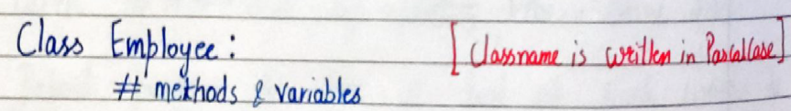

**🡺Object**

🡪An object is an instantiation of a class. When class is defined, a template(info) is defined. Memory is allocated only after object instantiation

🡪Objects of a given class can invoke the methods available to it without revealing the implementation details to the user and the process for doing it is called as the abstraction and encapsulation

🡺Modelling a problem in OOPs

🡪We identify the following in our problem

Noun 🡪 Class 🡪Employee

Adjective 🡪 Attributes 🡪 name, age, salary

Verbs 🡪 Methods 🡪 getSalary(), increment()

🡺Class Attributes

🡪An attribute that belongs to the class rather than a particular object

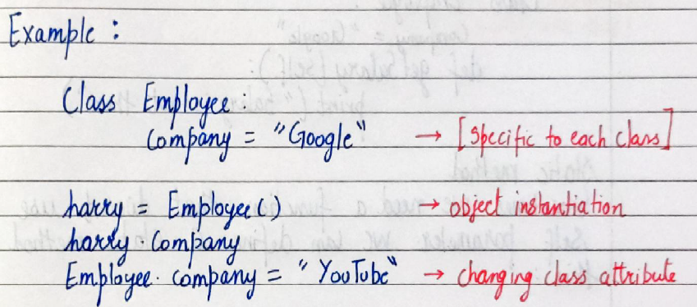

🡺Instance Attributes

An attribute that belongs to the instance(object) assuming the class from the previous example:

**harry.name=”Harry”**

**harry.salary=”30K”** 🡪Adding instance attributes

🡪Note: Instance attributes take preference over the class attributes during assignment & retrival

🡺’Self’ Parameter

🡪Self refers to the instance of the class. It is automatically passed with a function call from an object

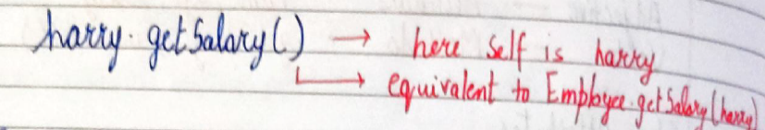

🡪The function getSalary is defined as:

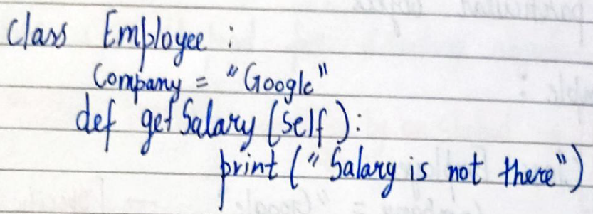

🡺Static Method:

🡪Sometimes we need a function that doesn’t use the self parameter. We can define a static method like this:

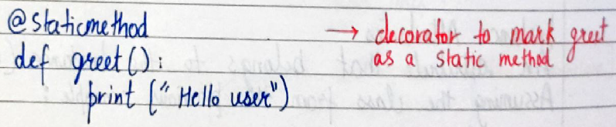

**🡺__init__() Constructor**

🡪 __init__() is a special method which is first run as soon as the object is created

🡪__init__() method is also known as the constructor

🡪It fakes self argument and can also take further arguments

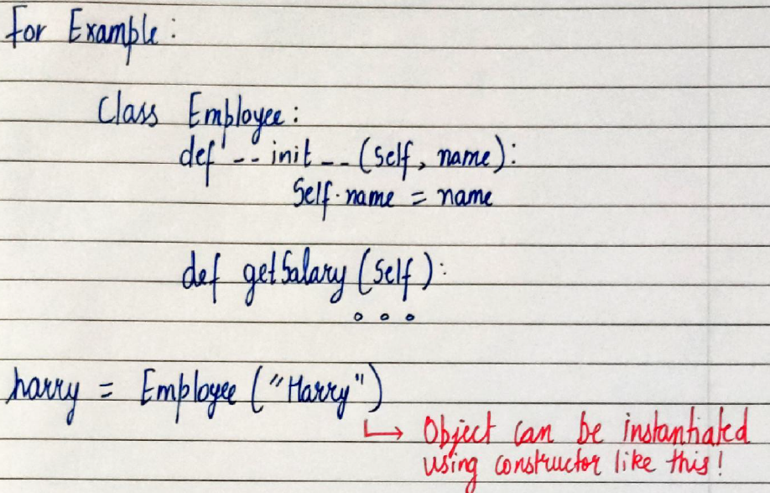

**(Chapter 11) Inheritance And More On Oops**

1. 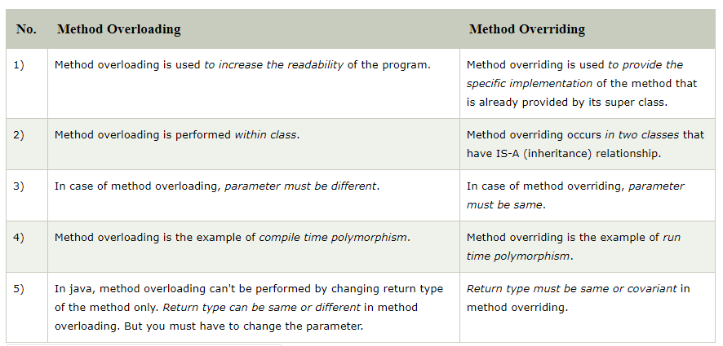

🡪Here priority of objects and methods is given to first class that is inherited, And that method is been not overrided to the existing one

🡪But if the method is overloaded by method of the same class, Than preference is given to the method of the current/working class

1. Inheritance is a way of creating a new class from an existing class

🡺Syntax:

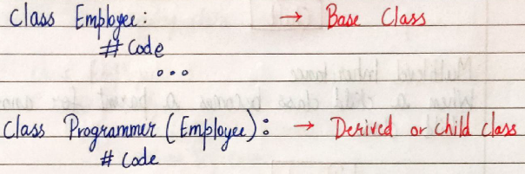

🡪We can use the methods and attributes of Employee in programmer object

🡪Also, we can overwrite or add new attributes and methods in programmer class

1. Type of Inheritance:
   1. Single Inheritance
   2. Multiple Inheritance
   3. Multilevel Inheritance
2. Single Inheritance:

🡪Single inheritance occurs when child class inherits only a single parent

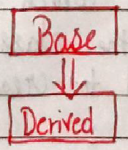

1. Multiple Inheritance:

🡪Multiple inheritance occurs when the child class inherits from more than one parent class

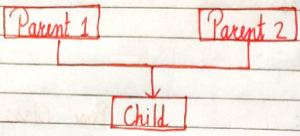

1. Multilevel Inheritance:

🡪When a child class becomes a parent for another child class

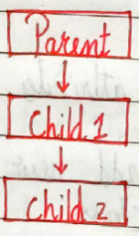

1. Super() method:

🡪super method is used to access the methods of a super class in the derived class

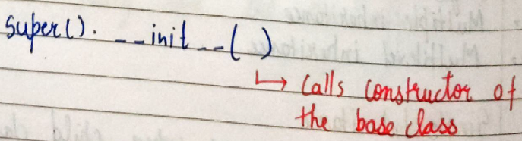

1. Class method:

🡪A class method is a method which is bound to the class and not the object of the class

**🡪@classmethod decorator** is used to create a class method

🡪Syntax to create a class method:

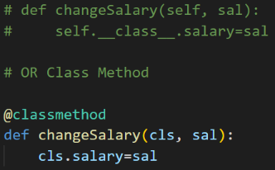

**🡪@property decorators:**

🡪For example consider the following class:

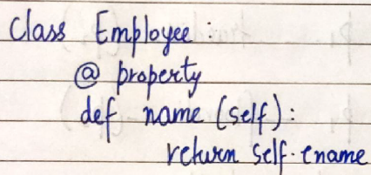

🡪if e=Employee() is an object of class employee, we can print(e.name) to print the ename/call name() function

🡪@.getters and @.setters:

🡪The method name with @property decorator is called getter method

🡪We can define a function+@name.setter decorator like below:

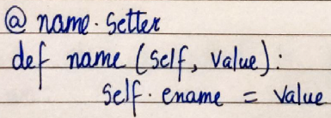

1. Operator overloading in python

🡪Operators in python can be overloaded using **dunder methods**

🡪These methods are called when a given operator is used on the objects, Operators in python can be overloaded using the following methods:

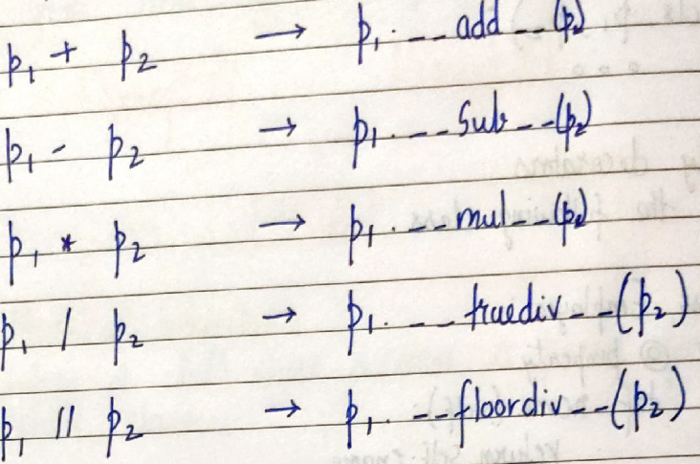

🡺Other dunder/magic methods in python:

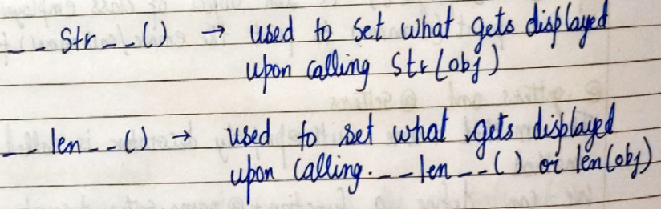

**(Chapter 12) Advance Python 1**

1. **Exception Handling in python**:

🡪There are many built-in exception which are raised in python when something goes wrong, exceptions in python can be **handled using a try statement**. The code that handles the exception is written in the **except clause**

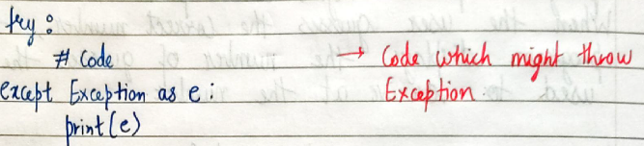

🡪When the exception is handled, the code flow continues without program interruption

🡪We can also specify the exceptions to catch like below:

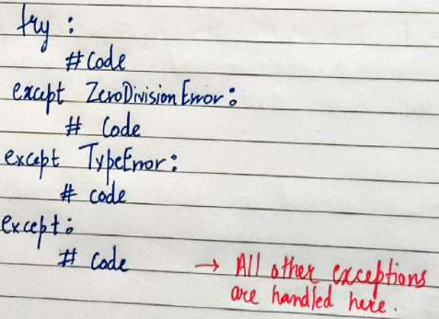

🡪Example:

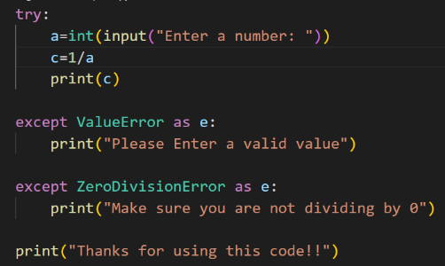

1. **Raising Exceptions:**

🡪We can raise custom exceptions using the raise keyword in python

🡪Example:

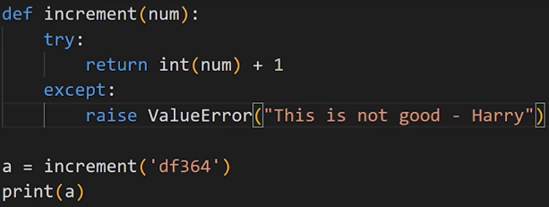

🡪Output:



1. **try with else clause:**

🡪Sometimes we want to run a piece of code when and when **only the try was successful** and for this purpose else statement’s code is used:

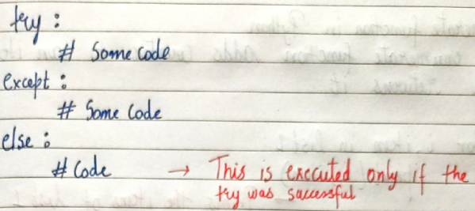

🡪Example:

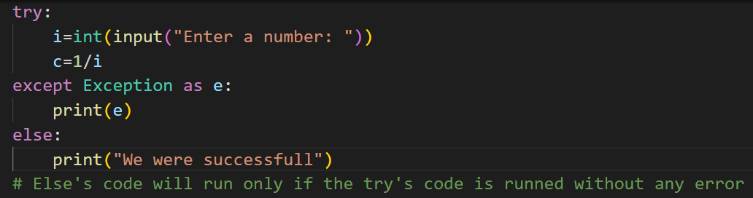

1. **Try with finally**

🡪Python offers a **finally clause** which ensures execution of a piece of code irrespective of the exception

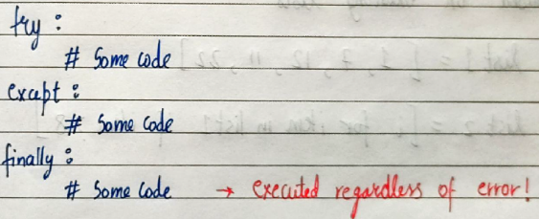

🡪Example:

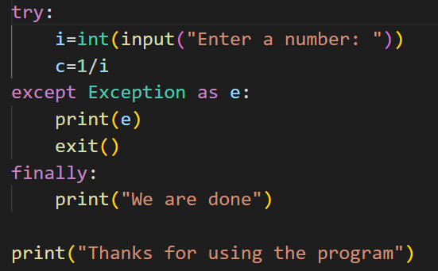

🡪Here, if the exception erupts when non- integer number is entered than the program will go to the exception part of the code and in it we have written the exit function, Than also the finally keyword’s code part will run and than only the program’s execution will stop

1. **if __name__==’__main__’ in python:**

🡪__name__ evaluates to the name of the module in python from where the program is run

🡪If the module is being run directly from the command line, the __name__ is set to string “__main__”. Thus this behaviour is used to check whether the module is run directly or imported to another file

🡪**Example:** (contains the two file example1 and example2, In which we have to use the first file’s greet named method, And the remaining content of the example1 file is to be shown or executed only when the file is opened by that file it self and of the example1 file is imported by the other file and being used than there is mechanism such that the other non-functioned things are not executed when called)

🡪Code of example1:

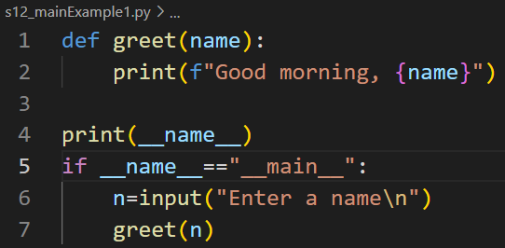

🡪Output of example1:

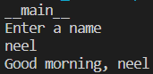

🡪Code of example2:

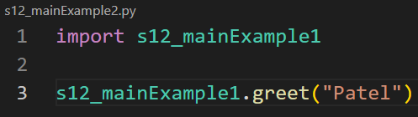

🡪Output of example2:

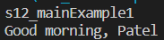

1. **global keyword:**

Global keyword is used to modify the variable outside of the current scope, If the variable is not commed in the argument, Than by help of the global keyword, we can use it in the out function and also can change the value of the variable

🡪Example:

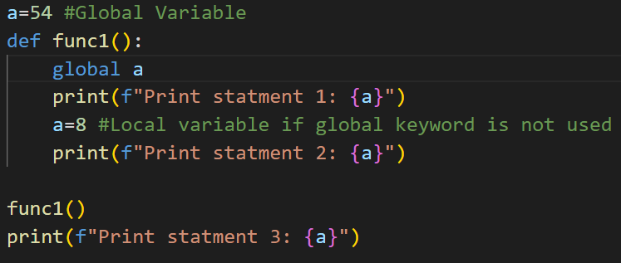

🡪Output:

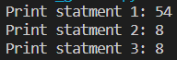

1. **enumerate function in python:**

🡪The enumerate function adds counter to an iterable and returns it

🡪The counter means that the enumerate method gives the **index number of the list** to which we are workin, And for that we have **to declare the two variables in the for loop**, In first one the value of the index will be stored and in the second one value at that particular index will be stored, Example of pseudo code is:

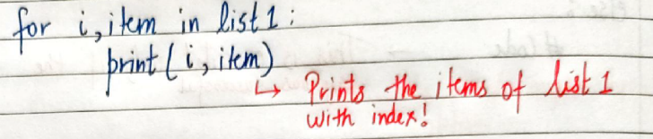

🡪Example:

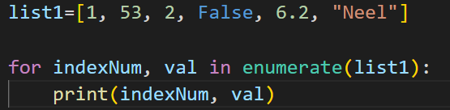

1. **list comprehensions**

🡪List comprehensions is an elegant way to create list based on existing lists

🡪By help of this method we can put the if statement and the for statement while making an list or any other same thing in the condition instead of the defining the value, Example of the pseudo code is as follow:

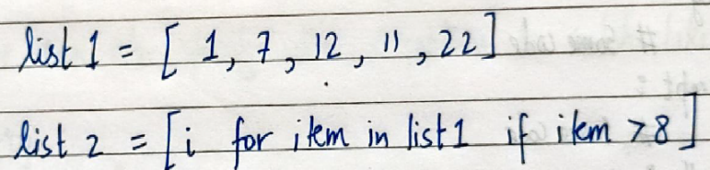

🡪Example of the code before and after the enhancement is:

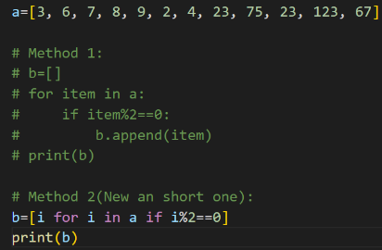

**(Chapter 13) Advance Python 2**

1. **Virtual Environment:**

🡪An environment which is same as the system interpreter but is isolated from the other python environment on the system

🡪**Installation**: (To use virtual environments, we write)

**pip install virtualenv** 🡪Install the package

🡪We create a new environment using:

**virtualenv myprojectenv** 🡪Creates a new environment

🡪Here the virtualenv is the name of the new environment, We can also put any other name also

🡪The next step after creating virtual environment is to activate it, And for it we have to write the following code in the compiler:



🡪Here the virtualenv is the name of the new environment, We can also put any other name also

🡪We can now use this virtual environment as a separate python installation

🡪We can know that the our new environment is made to be run or not by looking at the console, If the environment is made to run than the environment’s name is been made to be written in the terminal in the braces, As shown in the figure below:



🡪Now the environment made is the new and in it we have to install the required imports for our program, And this interpreter is different from the one that already exists in the local system, And we can make the more than one environments by help of this method

🡪And to de-activate the any of the non-system environment in which we are than we have to write the deactivate in the command prompt and than the in-built environment will start, For example:



🡪And if the environment is not in use, Than we can delete the non-system environment by simply deleting the folder that is made automatically by virtualenv in our project folder, And by doing that all the things related to that environment will be deleted, And it is recommended to delete it if not in use as it occupies so much space

1. **Pip freeze command**

🡪pip freeze returns all the packages installed in a given python environment along with the versions, Example:

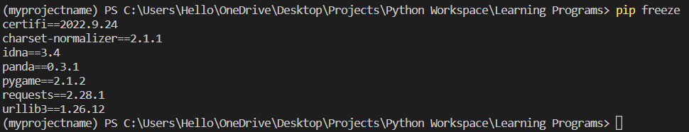

🡪And we can store these imports and their version in any file by using the following statement:

**“pip freeze > requirement.txt”**

🡪It is not compulsory to use the requirements.txt, We can also use any other name also

🡪The above command creates a file named requirments.txt in the same directory containing the output of the pip freeze

🡪Example of the file structure made is as shown below:

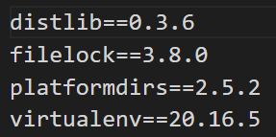

🡪We can distribute this file to other users and they can recreate the same environment using the following code as shown below:

**pip install -r requirments.txt**

🡪It is not compulsory to use the requirements.txt, We can also use any other name also by which we have stored the file that we have made using pip freeze

1. **Lambda Functions**

🡪Functions created using an expression using lambda keyword

🡪Lambda functions are also known as the enormous functions

🡪Syntax of lambda function:

**lambda arguments: expression**

Can be used as a normal function

🡪Example:

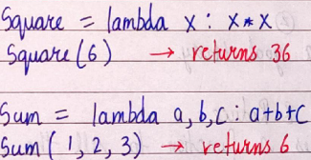

1. **Creates a string from inerrable objects(Join Method):**

🡪Creates a string from ite0072able objects:

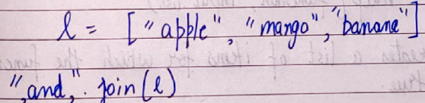

🡪The above line will return “apple, and, mango, and, banana”

1. **Format method (String)**

🡪Formats the value inside the string into a desired output

🡪This method is the old method that was used at the earlier times projects where the f string method was not introduced

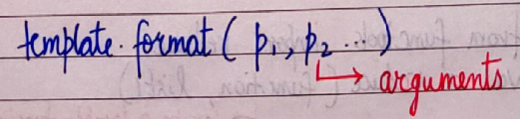

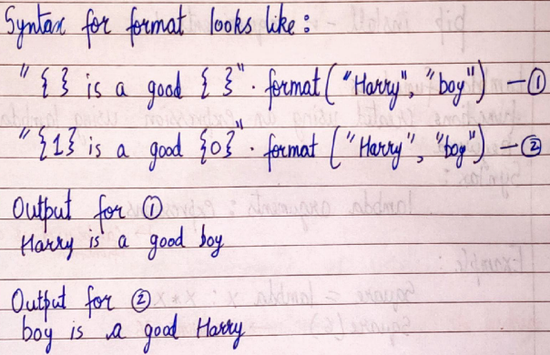

1. **Map, Filter, Reduce:**

🡪Map applies a function to all the items in an input_list

🡪Syntax:

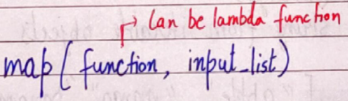

🡪Filter creates a list of items for which the function returns true

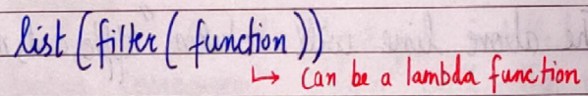

🡪 Example:

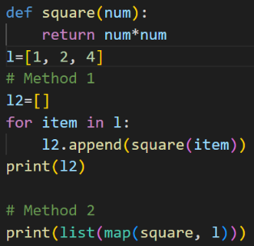

🡪Reduce applies a rolling computation to sequential pair of elements:

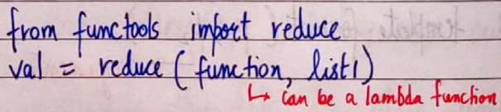

🡪If the function computes sum of two numbers and the list is [1, 2, 3, 4]

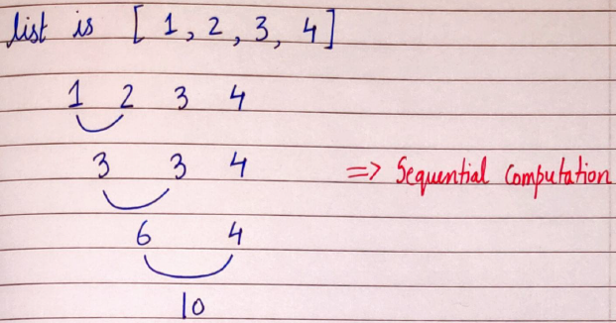

1. The **\*\*** operator is the exponential operator of the python, Example of it is as shown below:

